Chapter 6, Problem 51.

Determine L_{eq} at terminals a-b of the circuit in Fig. 6.73.

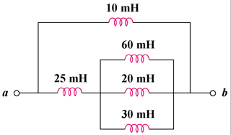

Figure 6.73
For Prob. 6.51.

